Project 2: Hybrid Connectivity Governance (Direct Connect + VPN)

Your office or data center needs a safe, reliable link to AWS. There are two main ways to build it, and this project says how to use both.
- Direct Connect: a private cable from your site to AWS. Fast and steady, but takes time to order.
- Site-to-Site VPN: an encrypted tunnel over the internet. Quick and cheaper, but speed can vary.
- Use both: Direct Connect is the main road and VPN is the backup road. If one breaks, traffic switches to the other.
- Your job: own the reference designs and the BGP rules that decide which road traffic takes.

Network diagram
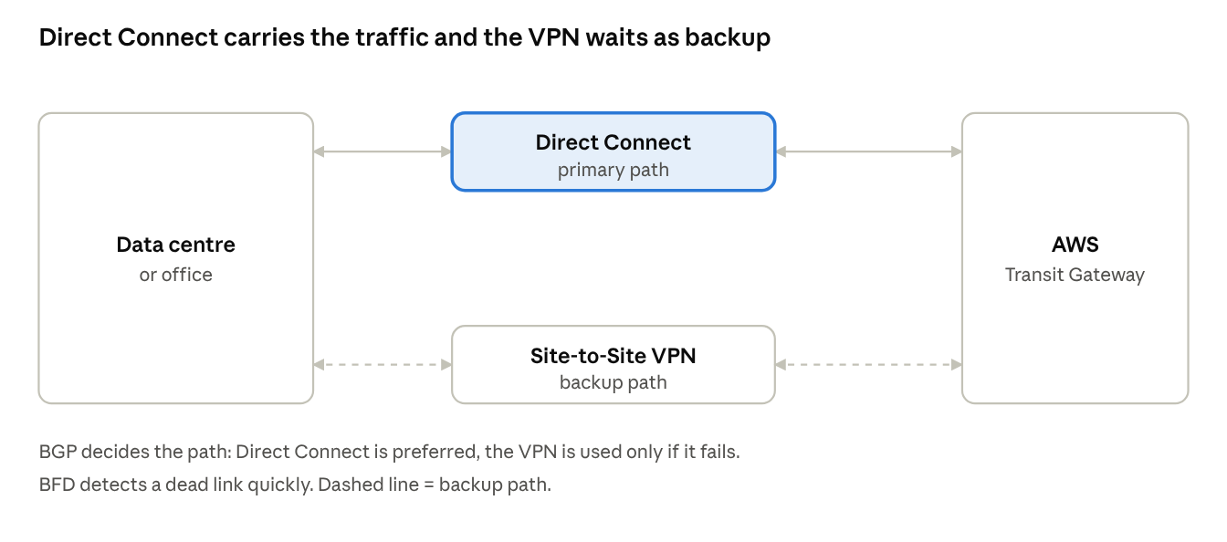
on-premises to AWS · primary and backup path
Direct Connect is the main path. The VPN is the backup that takes over if it fails.

BGP routing standards and traffic rules
BGP is how your network and AWS tell each other which IP ranges they can reach. These rules keep it predictable.
Rule | In simple words
Primary and backup | Direct Connect is preferred. The VPN is used only if Direct Connect fails.
Advertise only what is needed | Share summarized IP ranges, not every small network.
Fast failure detection | Turn on BFD so a dead link is noticed quickly.
Same rules everywhere | Every site uses the same BGP settings and naming.
Test failover | Practise pulling a link on purpose, before a real outage.

Production use case
Example scenario: a manufacturer keeps its ERP database in its own data centre. The new ordering app runs in AWS and reads from that database all day, and a large batch file moves each night.
- Direct Connect carries the daily traffic and the nightly batch.
- A VPN tunnel is always up as the backup.
- One day the Direct Connect link fails. BGP moves traffic to the VPN within moments.
- The app gets slower, because the VPN is slower, but orders keep flowing. The network team fixes the link.
Result: a cable fault becomes a slowdown, not an outage.

Interview questions and answers
Practice questions at the depth that senior cloud-network interviews at companies like AWS, Google and Meta expect. They are not official lists.
Q1. Design highly resilient connectivity between a data centre and AWS for a critical workload.
Use two Direct Connect locations with two connections in each, ending on separate devices. Connect them to a Direct Connect gateway and a Transit Gateway. Add Site-to-Site VPN as a further backup. This removes any single cable, device or site as a single point of failure.
Q2. How does traffic choose between Direct Connect and VPN?
The most specific prefix wins first. For equal prefixes, AWS prefers Direct Connect over VPN. On your side, you control the return path with BGP local preference. AS-path prepending shapes how AWS prefers paths for traffic coming to you.
Q3. How do you make failover fast and prove it works?
Turn on BFD so a dead link is found in seconds, instead of waiting for BGP timers. Then run planned failure tests: shut a link in a maintenance window and measure how long traffic takes to move. Record the result.
Q4. What are private, transit and public virtual interfaces?
A private VIF reaches one VPC. A transit VIF reaches Transit Gateways through a Direct Connect gateway. A public VIF reaches AWS public services. Multi-VPC designs normally use a transit VIF.
Q5. Is Direct Connect encrypted? What if the data must be?
Not by default. Options: MACsec on supported dedicated connections, or an IPsec VPN running over Direct Connect. Pick based on the compliance need and the throughput required.
Q6. Users report slow transfers after a failover. Where do you look?
Check whether traffic moved to the slower VPN, whether the return path is asymmetric, and whether MTU is consistent end to end. Compare latency and loss before and after the switch, and confirm BGP routes on both sides.

